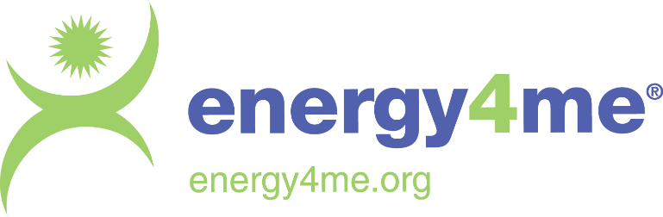

Section/Chapter Energy4me Activity Report

Fill this report for every Energy4me Activity your Section/Chapter does and send to energyed@spe.org to register you volunteer activity with SPE.

Energy4me Activity

Country | Click or tap here to enter text.
Section / Chapter Name | Click or tap here to enter text.
Type of Energy4me Event | Choose an item.
Number of Students | Click or tap here to enter text.
Date | Click or tap to enter a date.
Participating School/s | Click or tap here to enter text.
School contact (email) | Click or tap here to enter text.
Location | Click or tap here to enter text.
Sponsor : Yes ☐ No ☐ | Click or tap here to enter text.
Section Volunteers / SPE Member ID
i.e. Lou Rodriguez | i.e. 3527930
Click or tap here to enter text. | Click or tap here to enter text.
Click or tap here to enter text. | Click or tap here to enter text.
Click or tap here to enter text. | Click or tap here to enter text.
Click or tap here to enter text. | Click or tap here to enter text.
Click or tap here to enter text. | Click or tap here to enter text.
Click or tap here to enter text. | Click or tap here to enter text.
Click or tap here to enter text. | Click or tap here to enter text.
Click or tap here to enter text. | Click or tap here to enter text.
Click or tap here to enter text. | Click or tap here to enter text.
Multimedia

Photos | <<Insert Link to Access Photos>>
Videos | <<Insert Link to Access Videos>>
Overall Remarks :

* Energy4me Barrel of Knowledge contains essential energy4me experiment materials (i.e. beaker/graduated cylinder/slinky etc.)

